PROPOSAL

SIEGA CARLO
e-mail: sg.carlo@gmail.com
Tel. number: 0039 333 466 9385 (Italy)
0032 484 82 71 20 (Belgium)

https://www.facebook.com/carlosiega
https://soundcloud.com/carlo-siega
https://vimeo.com/carlosiega https://www.youtube.com/channel/carlosiega
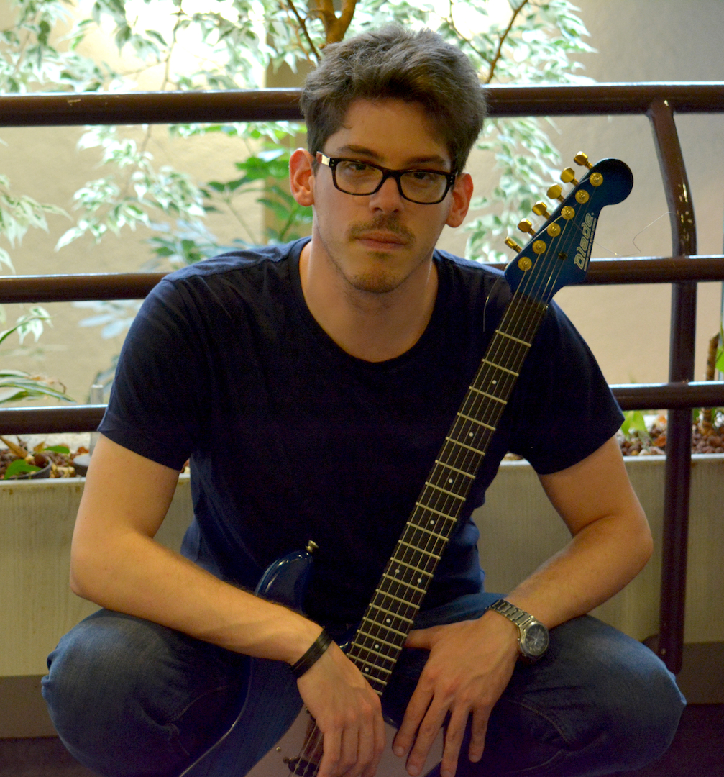

BODY-EXTENSIONS
Interpretation and reconstruction of solo pieces for live performance and fixed media

This presented project comes out from my activity of the last 3 years as a performer specialized in new music. I began to search different solutions of presenting contemporary compositions in a way that would be possible to show not only the intentions behind the pieces (through the interpretation) but also the processes throughout the compositions have been created. Starting from concepts concerning the situation on stage during a concert, and in connection with the development process of musical work, the instrumentalists are mostly involved in the compositional process, because their participation is itself part of the composition. I’m developing in Bruxelles a personal project where the body presence of the musician is one on the main themes involved. For this reason, one of the most important crux for my research in this sense is giving the visual perception of the musical event (employing live and/or pre-recorded audio and video material), in a way to return to the audience the temporal formation and coherence of the musical work, become perceivable and transparent.

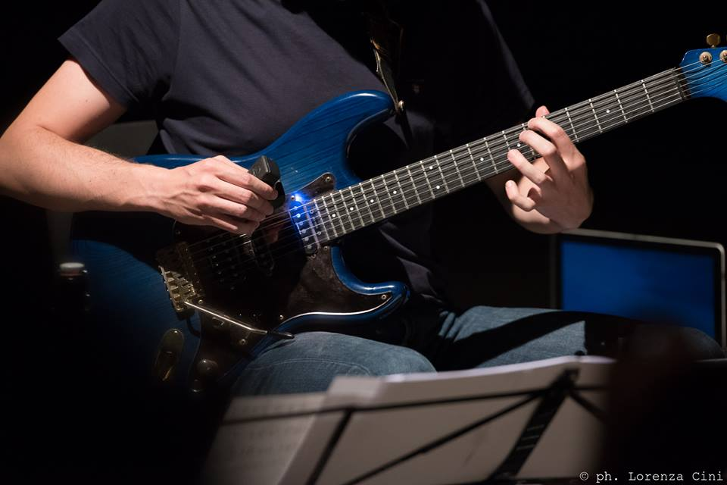

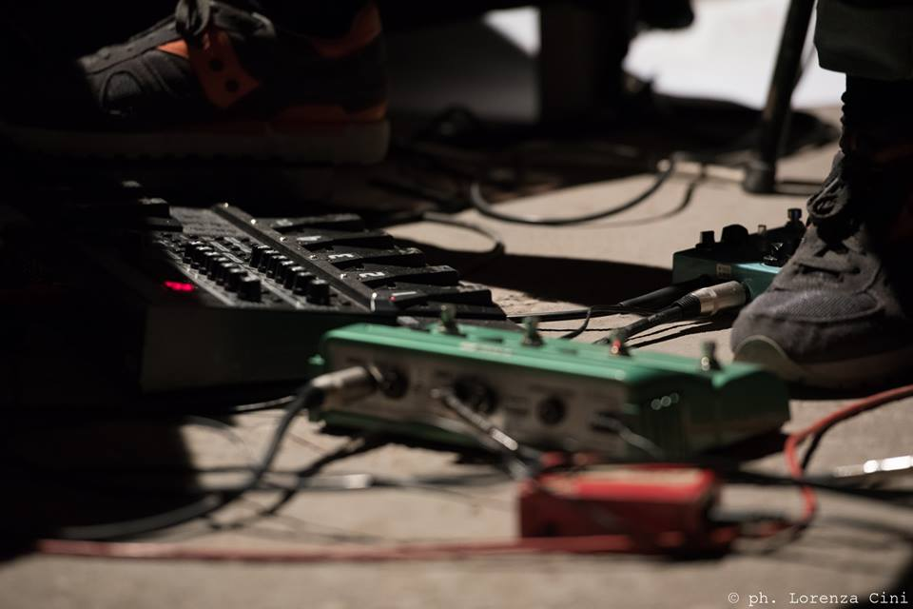

THE PROJECT
The selection of the pieces wants to explore the idea of limit in terms of control, especially on the relationship between the real performance given by the musician and the electronic interaction with him, and on grades of control that the musician has on the electronic machine in real time.

The starting point is the selection of different compositions that involve particular effects – like loops and delays – able to generate compositional ideas. Here, the guitarist is called to interface himself with the electronic in different levels, starting from one common point: every performance starts in a situation where the electric guitar serves as a “generator of sounds”. The “limit” itself represents that particular moment where technical, musical and physical gestures create the rough material for the final sound that will be expressed by the electronics.

The object of this research is to develop a specific framework in a way to create (firstly) and to give (lastly) a visual representation of the audio features. Finally, the main aims are:
1. Giving new interpretations of different pieces in which the fixed media became the common thought for the comprehension of the pieces.
2. Organizing a coherent program that can be able to link together pieces that may not have necessary the same nature and intentions into a one organic process.
3. Elaborating a concert that allows the audience following the musical process of the presented pieces during the entire performance throughout the connection of the acoustic and video senses.

The central point is the creation of an environment where the musician’s gestures and the body presence are intrinsically involved and considered during the performance. For this reason, the presence of the performer is crucial.

The final output will be a concert where the pieces will be presented as audio video pieces, as real audio/video installations.

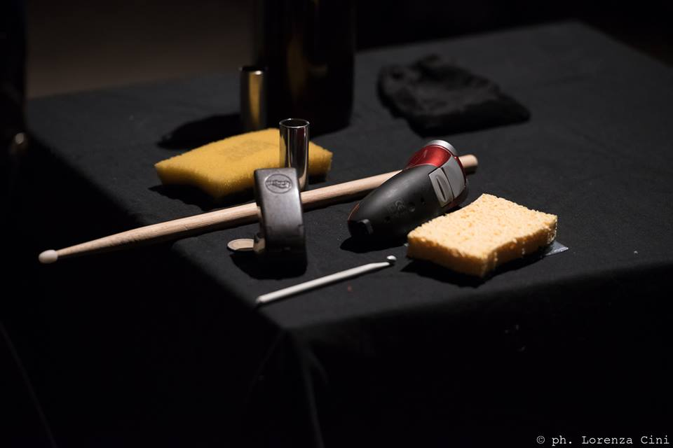
SCORE OF REFERENCE:

- B. Maderna (1920 - 1973): Serenata per un Satellite (1969), for E-guitar & random video-track* 6’ ca.
- M. Fiday (b. 1961): Slapback (1997), for E-guitar & video delay* 12’ ca.
- S. Beyer (b. 1981): Most of My Clients Come Back (2012-13), for E-guitar, objects, video looper & tape* 9’
- F. Romitelli (1963 - 2004): Trash TV Trance (2002), for E-guitar and video looper* 12’ ca.

*= version for video delay/loop has been thought and realised by Carlo Siega.

Audio Material (excerpt of the project’s pieces) can be downloaded here:
http://www.mediafire.com/file/f99v2wd20m91af7/Body-Extensions_Audio+excerpt.mp3

General Audio and Video Material can be listen and watched at the links on page 1.

ARTISTIC BIO

Bruxelles-based guitarist, after the Music Diploma in 2013, Carlo Siega obtained in 2014 the MA in Music Performance at the Conservatory “B. Marcello” in Venice with highest distinction. In the same year he resulted the first guitarist to receive the Stefano Vinti Scholarship Grant, given by the Venetian Conservatory for the best students. He studied Electric Guitar for the Contemporary Music at the “C. Abbado” School of Music in Milan under Francesco Zago (RepertorioZero Ensemble) from 2013 until 2015. He attended Masterclasses with Elena Càsoli, Tom Pauwels (Ictus Ensemble) and Yaron Deutsch (Nikel Ensemble).
He took part of the 47th and 48th Ferienkurse für die Neue Musik in Darmstadt (DE), the 9th Impuls Academy for Contemporary Music in Graz (AU), performing at the Time for Music Festival in Viitasaari (FL), Stagione del Teatro La Fenice (IT), and invited to play at the SIRGA Festival (Spain) in 2015.
He obtained the First Prize in the Contemporary Music Section at the 7° International Music Competition “Città di Treviso” (Italy) and a special mention for the interpretation of F. Romitelli’s Trash TV Trance at the Val Tidone International Competition (Italy). In 2016 he received the Research-led Performance Scholarship, given by the Fondazione Cini (Venice) and Orpheus Institut (Ghent).
He collaborates with many composers, premiering pieces by Pauline Oliveros, Klaus Lang, Giorgio Colombo Taccani, Giovanni Mancuso and Lorenzo Troiani among others.
He obtained also a Bachelor Degree in Philosophy with highest marks and distinction at the Ca’ Foscari University in Venice.
Admitted at the Advanced Master in Contemporary Music Performance promoted by the University of Ghent and ICUS Ensemble, he is working on his own research and performance project at P.A.R.T.S. (Bruxelles).
Technical Requirements

- 15W (at least) tube amplifier for guitar with send/return.
- Small stereo PA system (analog 6-channel Mixer desk -on stage-, 2 speakers).
- 4 XRL cables for the PA connections.
- 1 video projector.
- White screen (or a total white wall, at least).
- 2 low little tables.
- 1 empty bottle of wine.
- 2 Music stands.

IMPORTANT: The PA system will be set up on the flour, with the loudspeakers closed to the amplifier, in a way to obtain a very defined and localized spatialisation of the sound source.

Pieces’ explanation

Serenata per un Satellite
This is typical of Maderna’s approach, in music called as aleatory technique. It is a notational graphic score: that means the music presents a standard written notation, but it is graphically organised on the page. The idea of the piece is to have a set of different musical phrases or figures that have to be played in any order, together, or divided by small groups, or one instrument at a time (solo and ensemble versions are allowed, then). There is complete freedom in the construction of the piece, but the notes cannot be changed. The total duration is variable between 4 and 12 minutes.

Slapback
The composition is inspired by a live recording of The Who in which the guitarist plays a duet with himself as his sound echoes off the arena wall. In Slapback, the guitar performance – heard in the right stereo channel – is repeated, by means of an electronic delay unit, one eight note later in the stereo channel. While this conceit of exact repetition at a fixed temporal distance may initially strike one as being (merely?) a canon, is it actually quite different. The electronic repetition leaves musical features as volume and articulation unchanged, the short distance between statement and restatement create an intricate web of shifting accents and rhythms, especially when the piece veers off into more complicated and uneven metric structures.

Most of My Clients Come Back¹
In Most of My Clients Come Back, the composer works with live guitar performance, loops, and a mono playback tape. The tape speaker is placed right next to the guitar amplifier. The piece comes with click track, to coordinate pre-recorded material with live performance and loop structures. The texts, narrated by Neil Thomas Smith, come from two different sources: The first text has to do with theory of orchestration, with what one scholar refers to as Background and Accompaniment. The other text has to do with prostitution, it is extracted from an actual commercial dating profile of a 20-year-old male prostitute. Both texts on a surface level are congruent in their terms of Escort and Accompaniment, and yet they show structural similarities on deeper levels, speak of functionalism and hierarchical measuring of value. The speaking voice is applied several roles: as timbral colours in terms of orchestration and texture, as melodramatic elements (as in a radio play), and as self-referential comments on the piece’s own musical discourse and formal narration.

Trash TV Trance
Trash TV Trance exemplifies the composer’s ambivalence towards popular music while trying to appropriate popular musical language in order to reach a wide audience. The instrument’s rock culture is present on the stage and Romitelli plays off of the cognitive dissonance created by a rock instrument on the highbrow concert stage.
Divided into different sections and defined by different instrumental gestures, this piece is characterized by the addition throughout the repetition, on different levels. Through the use of a looping pedal that repeats short phrases recorded by the guitarist in real time, Romitelli engages in a critique of the repetitive music of popular culture. The repetition comes out from the micro-gestures where the guitarist has to build very short phrases. To continue the process and for adding more material, the composer forces the performer to start again from the beginning of the phrase. In the final section the guitarist constructs a complex loop that starts off sounding time, but overtime evolving into a cacophonous monstrosity of noise. While playing in time with the loop for a short time, the guitarist gradually accelerates out of sync with the loop until the tension between man and machine is too much to bear. Everything stops abruptly, as if interrupted. Then… Silence.

¹ Note of the composer.

